Git

**What is Git Repository?**

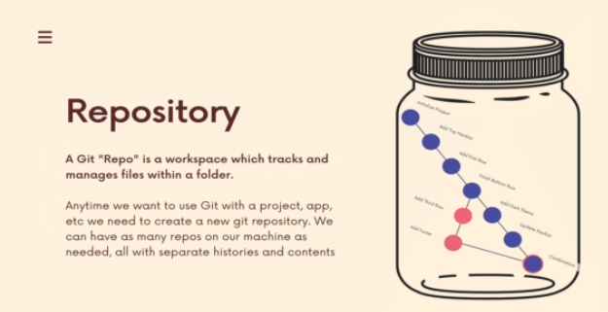

**Commit Workflow**

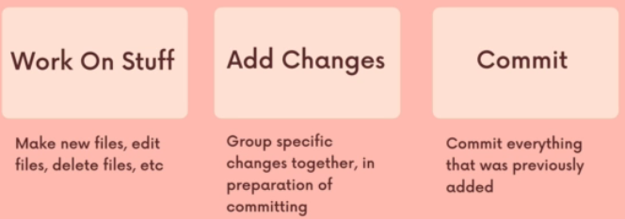

**Adding Files to staging area**

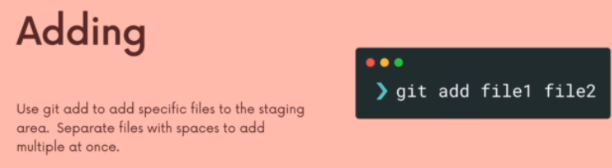

**Git Commit with Message**

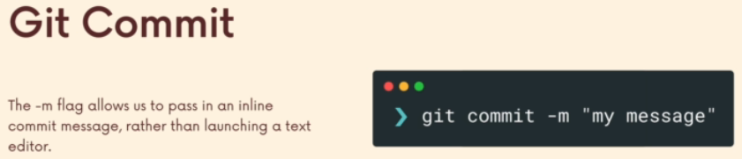

Git Log - check log of the commits.

Atomic Comments

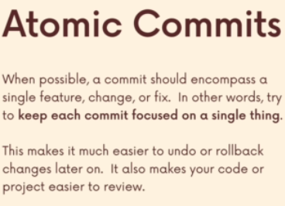

**Amending Comments**

Works only for last commit.

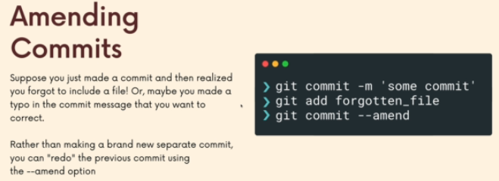

**Branching in Git**

Head -- Points to the recent commit for the branch.

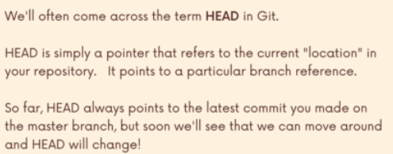

git branch -> to view the branches created

**Create the branch**

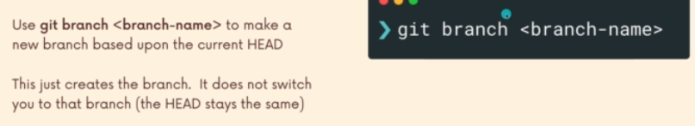

**Switch to the branch**

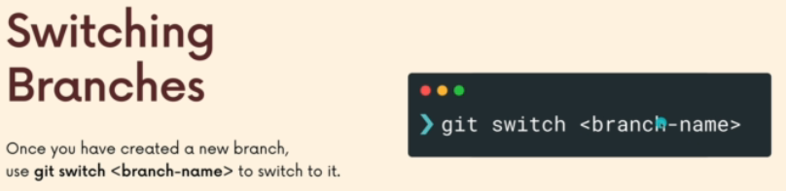

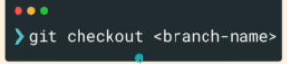

**Merging Branches**

1. **Fast Forward Merge**